CHAPTER 5

TEACHING NOTES

Chapter 5 is short, but it is conceptually more difficult than the earlier chapters, primarily because it requires some knowledge of asymptotic properties of estimators. In class, I give a brief, heuristic description of consistency and asymptotic normality before stating the consistency and asymptotic normality of OLS. (Conveniently, the same assumptions that work for finite sample analysis work for asymptotic analysis.) More advanced students can follow the proof of consistency of the slope coefficient in the bivariate regression case. Section E.4 contains a full matrix treatment of asymptotic analysis appropriate for a master’s level course.

An explicit illustration of what happens to standard errors as the sample size grows emphasizes the importance of having a larger sample. I do not usually cover the LM statistic in a first-semester course, and I only briefly mention the asymptotic efficiency result. Without full use of matrix algebra combined with limit theorems for vectors and matrices, it is very difficult to prove asymptotic efficiency of OLS.

I think the conclusions of this chapter are important for students to know, even though they may not fully grasp the details. On exams I usually include true-false type questions, with explanation, to test the students’ understanding of asymptotics. [For example: “In large samples we do not have to worry about omitted variable bias.” (False). Or “Even if the error term is not normally distributed, in large samples we can still compute approximately valid confidence intervals under the Gauss-Markov assumptions.” (True).]

SOLUTIONS TO PROBLEMS

5.1 Write y = 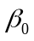 + 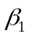x₁ + u, and take the expected value: E(y) = + E(x₁) + E(u), or µ_{y} = + µ_{x} since E(u) = 0, where µ_{y} = E(y) and µ_{x} = E(x₁). We can rewrite this as = µ_{y} - µ_{x}. Now, 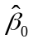 = − 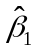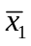. Taking the plim of this we have plim() = plim( − ) = plim() – plim()plim() = µ_{y} − µ_{x}, where we use the fact that plim() = µ_{y} and plim() = µ_{x} by the law of large numbers, and plim() = . We have also used the parts of Property PLIM.2 from Appendix C.

5.2 A higher tolerance of risk means more willingness to invest in the stock market, so 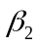 > 0. By assumption, funds and risktol are positively correlated. Now we use equation (5.5), where δ₁ > 0: plim(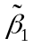) = + δ₁ > , so has a positive inconsistency (asymptotic bias). This makes sense: if we omit risktol from the regression and it is positively correlated with funds, some of the estimated effect of funds is actually due to the effect of risktol.

5.3 The variable cigs has nothing close to a normal distribution in the population. Most people do not smoke, so cigs = 0 for over half of the population. A normally distributed random variable takes on no particular value with positive probability. Further, the distribution of cigs is skewed, whereas a normal random variable must be symmetric about its mean.

5.4 Write y = + x + u, and take the expected value: E(y) = + E(x) + E(u), or µ_{y} = + µ_{x}, since E(u) = 0, where µ_{y} = E(y) and µ_{x} = E(x). We can rewrite this as = µ_{y} − µ_{x}. Now, 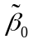 = − . Taking the plim of this we have plim() = plim( − ) = plim() – plim()⋅plim() = µ_{y} − µ_{x}, where we use the fact that plim() = µ_{y} and plim() = µ_{x} by the law of large numbers, and plim() = . We have also used the parts of the Property PLIM.2 from Appendix C.

SOLUTIONS TO COMPUTER EXERCISES

C5.1 (i) The estimated equation is

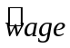 = −2.87 + .599 educ + .022 exper + .169 tenure
(0.73) (.051) (.012) (.022)
n = 526, R² = .306, 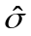 = 3.085.

Below is a histogram of the 526 residual, 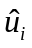, i = 1, 2 , ..., 526. The histogram uses 27 bins, which is suggested by the formula in the Stata manual for 526 observations. For comparison, the normal distribution that provides the best fit to the histogram is also plotted.

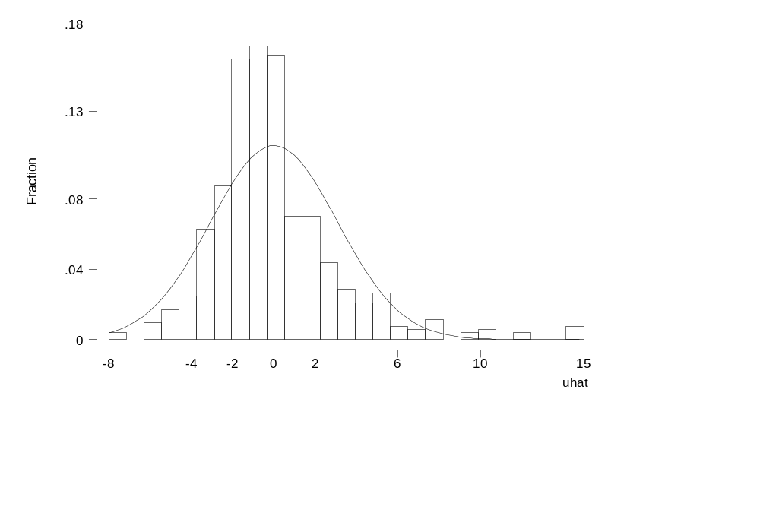
(ii) With log(wage) as the dependent variable the estimated equation is

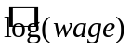 = .284 + .092 educ + .0041 exper + .022 tenure
(.104) (.007) (.0017) (.003)
n = 526, R² = .316, = .441.

The histogram for the residuals from this equation, with the best-fitting normal distribution overlaid, is given below:

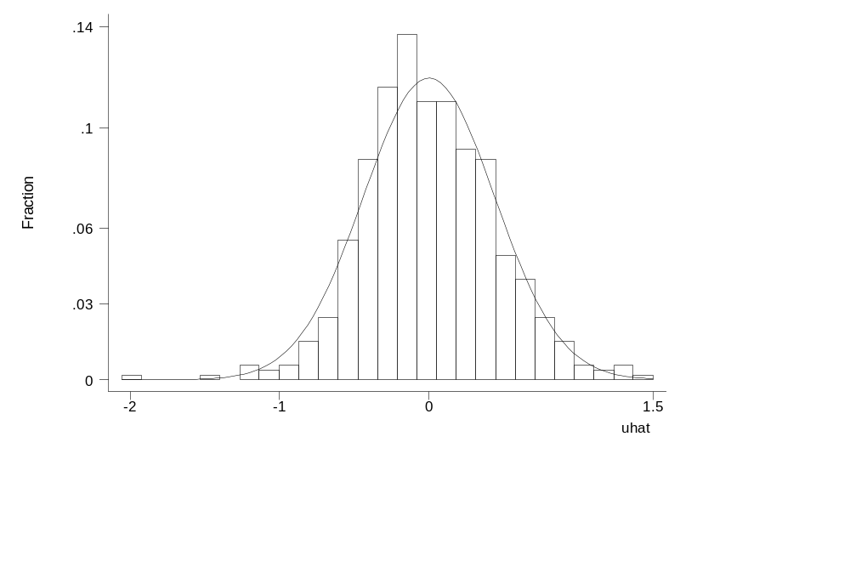

(iii) The residuals from the log(wage) regression appear to be more normally distributed. Certainly the histogram in part (ii) fits under its comparable normal density better than in part (i), and the histogram for the wage residuals is notably skewed to the left. In the wage regression there are some very large residuals (roughly equal to 15) that lie almost five estimated standard deviations ( = 3.085) from the mean of the residuals, which is identically zero, of course. Residuals far from zero does not appear to be nearly as much of a problem in the log(wage) regression.

C5.2 (i) The regression with all 4,137 observations is

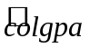 = 1.392 − .01352 hsperc + .00148 sat
(0.072) (.00055) (.00007)
n = 4,137, R² = .273.

(ii) Using only the first 2,070 observations gives

= 1.436 − .01275 hsperc + .00147 sat
(0.098) (.00072) (.00009)
n = 2,070, R² = .283.

(iii) The ratio of the standard error using 2,070 observations to that using 4,137 observations is about 1.31. From (5.10) we compute 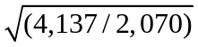 1.41, which is somewhat above the ratio of the actual standard errors.

C5.3 We first run the regression colgpa on cigs, parity, and faminc using only the 1,191 observations with nonmissing observations on motheduc and fatheduc. After obtaining these residuals, 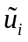, these are regressed on cigs_{i}, parity_{i}, faminc_{i}, motheduc_{i}, and fatheduc_{i}, where, of course, we can only use the 1,197 observations with nonmissing values for both motheduc and fatheduc. The R-squared from this regression, 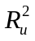, is about .0024. With 1,191 observations, the chi-square statistic is (1,191)(.0024) 2.86. The p-value from the 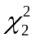 distribution is about .239, which is very close to .242, the p-value for the comparable F test.

